

Some Useful Excel Functions for Modeling

SUM and SUMPRODUCT IF and COUNTIF VLOOKUP



Some Useful Excel Functions for Modeling

◆ **Additional Functions:**

◆ SUM:

◆ Function that adds up all of the numbers in a range of cells.

◆ =SUM(*range)*

◆ SUMPRODUCT:

◆ Function that returns the sum of the products of elements in a set of arrays.

◆ =SUMPRODUCT(*array1, array2)*

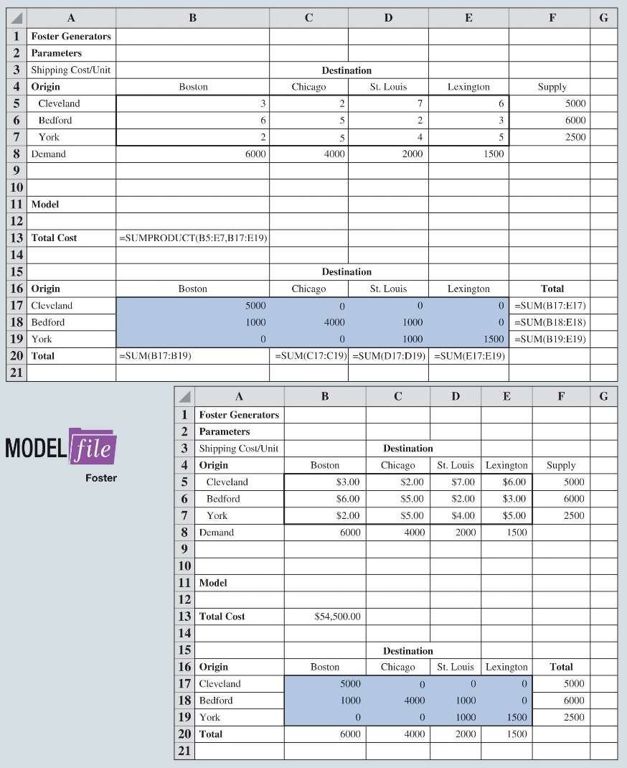

Some Useful Excel Functions for Modeling

Figure 10.16: What-If Model for Foster Generators

◆ Each element of one array is multiplied by corresponding element of the other array

B5*B17+C5*C17 + D5*D17 + E5*E17 +B6*B18 +…+ E7*E9



Some Useful Excel Functions for Modeling

◆ **Additional Functions:**

◆ =IF(condition, result if condition is true, result if condition is false).

◆ =IF(B16>=$B$10, $B$11*B6, B6)*B16

◆ =COUNTIF(range, condition).

◆ Counts the number of components having a positive order quantity.

◆ =COUNTIF(B16:E16, “>0”)

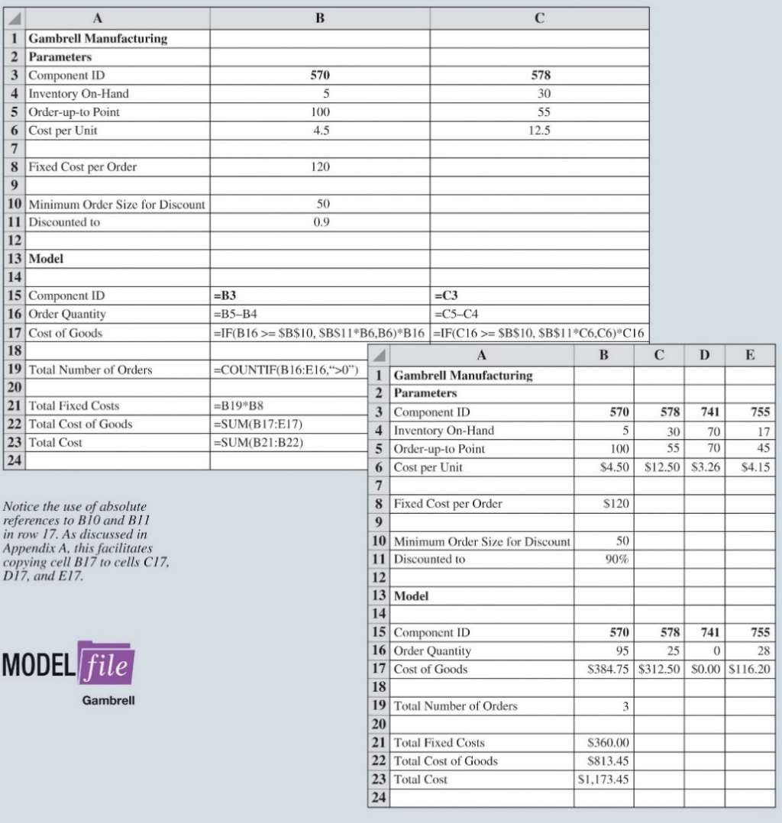

Some Useful Excel Functions for Modeling

Figure 10.17: Gambrell Manufacturing Component Ordering Model

◆ Illustration:

◆ Gambrell Manufacturing produces car stereos.

◆ Gambrell likes to keep its components inventory to a minimum.

◆ Hence, it uses an inventory policy known as an order-up-to policy.

◆ Whenever the inventory on hand drops below a certain level, enough units are ordered to return the inventory to that predetermined level.



Some Useful Excel Functions for Modeling

◆ **VLOOKUP**

◆ This function allows the user to pull a subset of data from a larger table of data based on some criterion.

◆ General form =VLOOKUP(value, table, index, range) where,

◆ value = the value to search for in the **FIRST** column of the table.

◆ table = the cell range containing the table.

◆ index = the column in the table containing the value to be returned.

◆ range = TRUE if looking for the first approximate match of value

◆ FALSE if looking for an exact match of value.

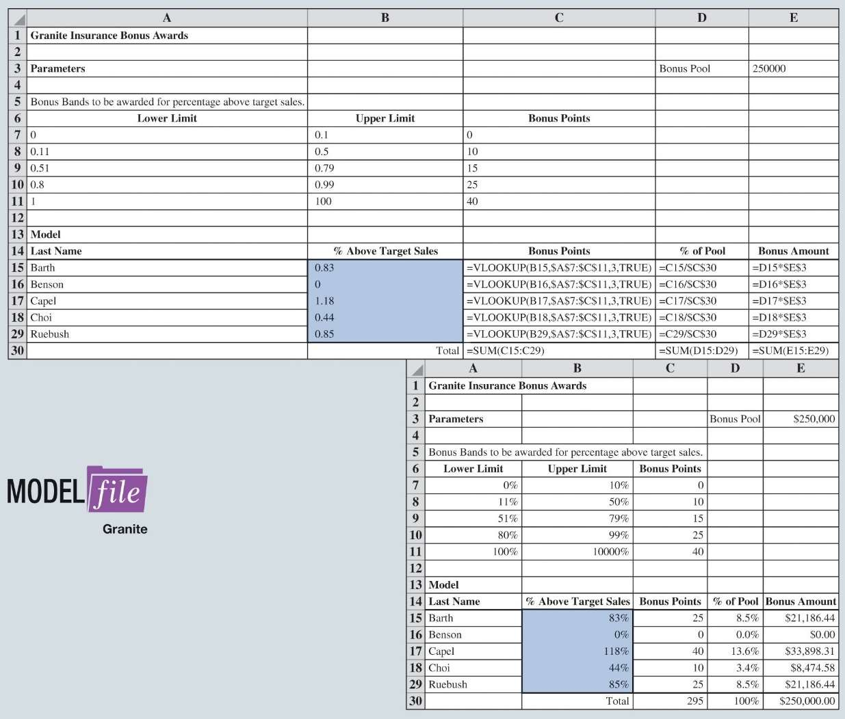

Some Useful Excel Functions for Modeling

Figure 10.18: Granite Insurance Bonus Model